Energy Internet & "One Belt One Road" Summit 2016 is Drawing Near

The preliminary draft for China's energy Internet action plan has been completed with the formal plan likely to come out within this year. The energy Internet related market scale is expected to exceed 5 trillion yuan, predicted industry insiders. The combination of energy and Internet has become a mainstream thinking under the country's "Internet Plus" strategy and China is likely to encourage various pilot projects to achieve higher efficiency in using renewable energy such as wind power and solar PV power in a bid to replace polluting coal, according to an informed source.

The Energy Internet Summit 2016 will address the most crucial issues that will determine your performance objectives in China and the world and we strongly believe this conference will generate some valuable advices to assist you to gauge the pulse of this ever-changing industry and grasping the latest and most advanced product information.
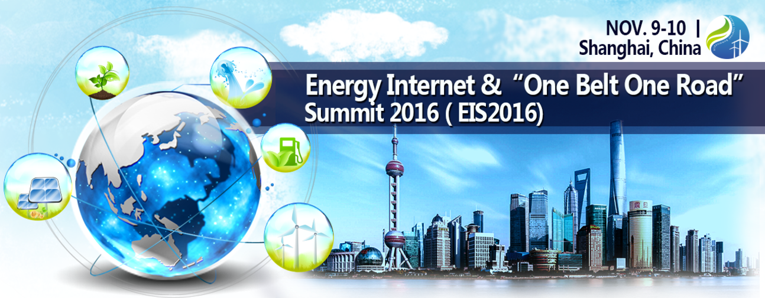

How to understand these topics, and divide a cup of a thick soup from wave of the energy Internet ?

Energy Internet & "One Belt One Road" Summit 2016 (EIS2016)will bring you a comprehensive answer. The conference will make landfall on November 9 -10, 2016 in Shanghai, China. There will be 300+ Delegates，30+ Exhibitors，25+ Keynote Speakers and discussions, participation in interactive communications, seminar the Chinese and global energy Internet strategy under "One Belt One Road", interpreting industry trends and hot topics, sharing advanced technology and project experience. You can't miss it!

【Key Topics】
The Landscape of the Energy Interest Industry and its Opportunity and Challenges
Enterprises Transformation and Upgrading Under the New
Development Trend and Key Technology
Industrial Standards Business Model and Market Application
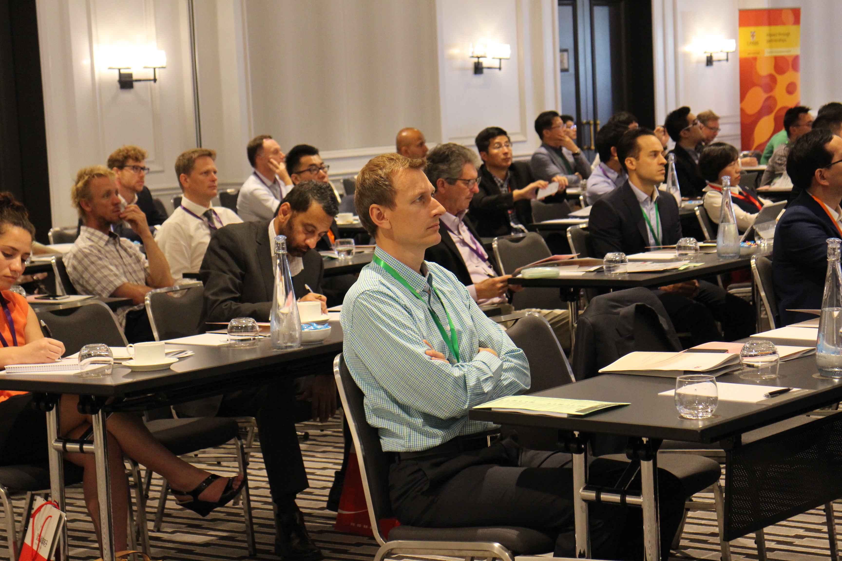

【Who will attend】
Government & Regulators
Assoications
Investor and Financers
Form a complete set of equipment and service providers

【Key Customers】
C3 IoT、H3C Technologies Co., Limited、infiswift Inc、RTI、Combine Energy、Eaton、Jinko、East Environment Energy、Simens、Envision、Sungrow、ENN、CLOU Electronics Co., Ltd.、GCL、ZTE、HUAWEI、NARI、ZHONHEN、LINYANG、KEHUA、TELLHOW、FESE、AKCOME、Risen、SIFANG、Accenture、Aoyipower、AutoGrid、Infineon Technologies AG，etc.

Contact Us：Jane Chen
Mobile：021-68407631
Email：esa@cdmc.org.cn

About CDMC：
China Decision Makers Consultancy（CDMC）is the first and the largest professional conference organizer in Asia. Since founded in 2004, CDMC has successfully organized hundreds of events, conferences and exhibitions with tremendous attendance. CDMC has millions of decision makers’ database. We witnessed the rapid growth of Chinese market in the past 12 years. On May 2016, CDMC was listed on National Equities Exchange and Quotations (Chinese OCT Equities Markets)， stock code: 837621.

CDMC Events covers around 10 industries, including Energy & New Energy, Transportation, Infrastructure, Retail, Entertainment, Finance, Real Estate, Healthcare, Manufacturing and IT. We’re able to build a unique bridge between your business and regulators in China available nowhere else as we have a powerful advisory team including China's highest-ranking government officials, illustrious scholars, and industry experts.

Click http://www.eis-annual.com/en to get more information about the events!

