The Spring of Australian Household Energy Storage
——ESA2016 Australia Energy Storage Conference is Drawing Near
At the end of 2015, Australian rooftop solar system installation has exceeded more than 1.5 million households. The electricity price is 5-8 Australian dollars points and in this case, the number of users increased ten thousand per month.
About 1.5 million kWh of energy storage market can be expected, while the government photovoltaic (PV) subsidy contract covering 300 thousand users will expire in 2016.

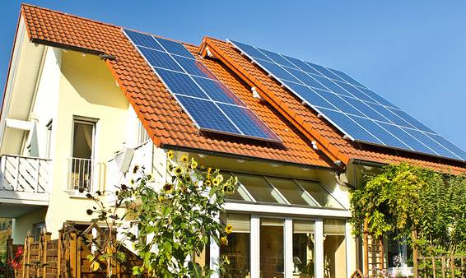

In 2017, the small energy storage system with the rooftop PV system will have a installed capacity of about 500 thousand kWh. By 2020, the retail price of the small energy storage system is expected to fall at 0.9 Australian dollars/ Wh, according to the authority of AEMO (Australian Energy Market Operater).

Facing the huge market demand
What kind of energy storage products are more suitable for customers in Australia?
What certification testing is necessary for the energy storage products to enter Australian market?
How can the energy storage products be sold to the Australian consumers? Directly, through distributor, or through the electricity retailers? What kind of sales model is more suitable for you?

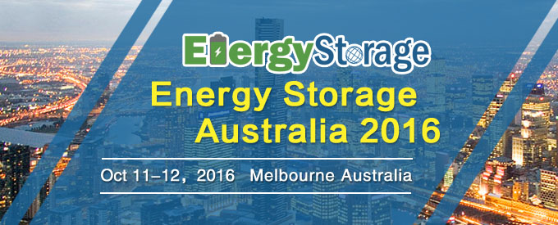

7th Energy Storage Australia Conference & Exhibition (ESA2016)will bring you a comprehensive answer. On the basis of successful experience in 2014 and 2015, the conference will make landfall on October 11 -12, 2016 in Melbourne, Australia. This conference will talk about the worldwide solar power grid and energy storage application areas within the scope of government organization, association, power grid companies, power companies, energy companies, mine owners and other project owner units, research institutes, energy storage battery manufacturers, photovoltaic (pv ) & energy storage system integrator and solution provider, material suppliers, etc.

350+ Delegates
20+ Exhibitors
30+ Keynote Speakers
30+ Battery Distributors
20+ Australia’s Electric Power Retail Company

Participation in interactive communications, interpreting industry trends and hot topics, sharing advanced technology and project experience. You can't miss it!

Key Topics
- Status and development trends of worldwide renewable energy
- The government's policy support, supervision of photovoltaic (PV ) + energy storage, certification, and incentives
- Power grid companies, energy companies and photovoltaic (PV ) + battery energy storage project demonstration and introduction
- Distributed energy storage and rooftop photovoltaic (PV ) case sharing
- Batteries, inverters, battery management systems and other technologies discussion and products release
- Australia's energy storage market financing and business model exploration

Highlights:

If you already have your own energy storage products, please bring your products to show on the summit, the summit will also arrange professional one to one meeting and luncheon for sponsors and delegates.

Who will attend

Government & Regulators
Assoications
Grid Operators & Renewable Energy Companies
Contractors
Energy Storage Projects Owners
Energy Retailors
Electric Power Research Institute
Green Community Developers
Companies Needs Uninterruptible Power Supply (e.g. Miners)
Investor and Financers
Battery Manufacturers & BMS，PCs, Inverter Manufacturers
Sales Distributors of Battery, BMS，PCs and Inverter

Australian local companies confirmed or under inviting, please look forward to more!
AGL、Australia Energy Regulator、Australian Government Department of Environment、Australian Greens、Australia Renewable Energy Agency (ARENA)、Ausgrid、Citipower、Clean Energy Council (CEC)、CSIRO、Department of Energy、 United States of America (DOE)、ElectraNet Pty Ltd、Endeavour Energy、Energex、EnergyAustralia、Ergon Energy、Essential Energy、FirstSolar、Grid Australia、Green Energy Trading、Hydro Tasmania、SP AusNet、Powerlink Queensland、United Energy、Western Power, etc.

Contact Us: Jane Chen
Mobile: +86 021 68407631 * 8116
Email: janech@cdmc.org.cn
Skype: cxjtravel

About CDMC：

China Decision Makers Consultancy（CDMC）is the first and the largest professional conference organizer in Asia. Since founded in 2004, CDMC has successfully organized hundreds of events, conferences and exhibitions with tremendous attendance. CDMC has millions of decision makers’ database. We witnessed the rapid growth of Chinese market in the past 12 years. On May 2016, CDMC was listed on National Equities Exchange and Quotations (Chinese OCT Equities Markets), stock code: 837621.

CDMC Events covers around 10 industries, including Energy & New Energy, Transportation, Infrastructure, Retail, Entertainment, Finance, Real Estate, Healthcare, Manufacturing and IT. We’re able to build a unique bridge between your business and regulators in China available nowhere else as we have a powerful advisory team including China's highest-ranking government officials, illustrious scholars, and industry experts.

Click http://www.esa-annual.com/en to get more information about the events!

